Report

Project of week 4 and 5 on the data analytics bootcamp at Ironhack

Comparison of decriminalization on drug abuse related deaths and drug related crime in European countries and a broad estimate for tax revenues of a chosen European state in case of legalization and taxation of recreational marijuana with basis on the evolution of tax revenues in Colorado from 2014

The primary findings of this report are based on the analysis of datasets from Eurostats. A dataset with the causes of deaths per country has been used to retrieve data on the drug related deaths and alcohol related deaths per 100 000 persons for the European countries [1] and a dataset containing the crimes committed was the bases for the analysis for drug related crimes [1] (both in csv format). Beyond that another statistical report released by Eurostats was used simply for comparison with the other findings. The secondary research involved various sources including surveys about cannabis and further drug consumption and the research included sources about tax revenues of recreational marijuana taxes in Colorado [2].

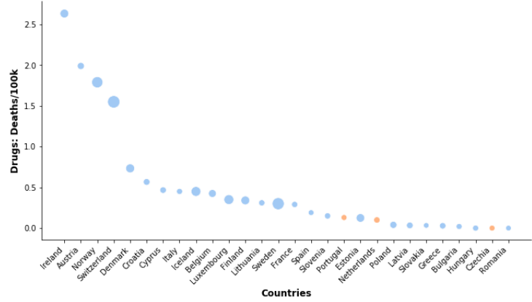
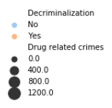
The primary goal of this analysis was to find out in whether countries in Europe with drug decriminalization policies may have comparably higher or lower drug related deaths and drug related crime in comparison to other European countries. Beyond that it was examined whether further correlations were to be found within the chosen data. After cleaning the data, first, the alcohol and drug related deaths were extracted from the data and first plots over time didn’t reveal any particular trends. Then the statistical report with information on later years was analyzed in order to compare it with the other tables. The information of all tables was merged into one table and the possible correlations within the data were searched. The data can be well summarized with the following figure 1 showing the drug related deaths [deaths per 100 000 people] per country. The countries marked in orange represent the countries with some form of decriminalization.
It can be seen that the countries with some form of decriminalization have low values of drug related deaths and low values of drug related crimes (Thickness of the bubbles). However, it has to be pointed out that the number of countries with some form of decriminalization is low
Fig.1: Plot of drug related deaths and crimes per country
and while the rates of drug related deaths in these countries are low, in combination with the low number of countries with kinds of decriminalization the death and crime rates are not low enough to be a striking proof nor a strong correlation, though it should be mentioned that these countries still show a considerable tendency at least. This is also what can be inferred from the following figure 2:
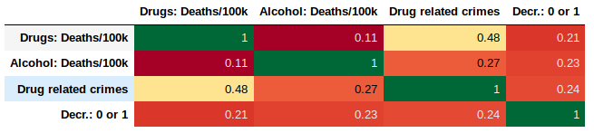
Fig.2: Correlation table
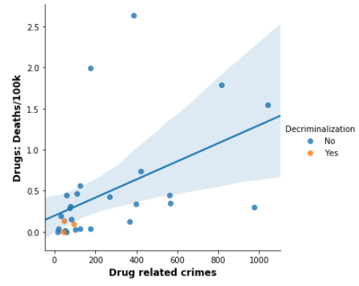
There doesn’t seem to be any outstanding correlation. With around 0.5 the drug related crimes and the drug related deaths seem to correlate to a notable degree. This can be seen in a tangible way in the following figure 3, in which the drug related crimes and drug related deaths are plotted against one another:
The graph shows us that the interpolation has wide margins due to the partially scattered dots. However, it also shows that when we consider both factors, drug related deaths and drug related crime, the countries with some form of decriminalization seem to perform even better in comparison as all three are in the bottom left corner.

Fig.3: Plot of drug related crimes vs. drug related deaths.

The extra part of this analysis is hypothetical and slightly speculative in so far that it highlights facets of partial legalization by aiming to create a broad estimate for the tax revenues created if an European country legalized recreational marijuana and taxed it. This estimate is based on the evolution of tax revenues of marijuana taxes in the state of Colorado and therefore it is based on the premises that the evolution of tax revenues would follow a similar development in a European state under the further circumstance that it would also have a similar rate and similar system of taxation. As an exemplary country to do this analysis I chose Germany.
In order to find out how the sale of cannabis in the different culturally and economically different environment of Germany would compare to the first year of sales of cannabis in Colorado I looked into two surveys. A survey about the use of marijuana in 2014 - directly in the beginning of the legalization of it in Colorado – undertaken by the department of health and public health and environment [3]. And a survey by the German institution Aerzteblatt that did an epidemiological survey on the use of tobacco, alcohol and drugs in 2017 [4]. It shows that regular use of cannabis was around 13% in Colorado in 2014 and that the use of cannabis at least once within the last 12 months in Germany was at around 7%, though the black count may be higher, as seen in the following figures 4a,b:
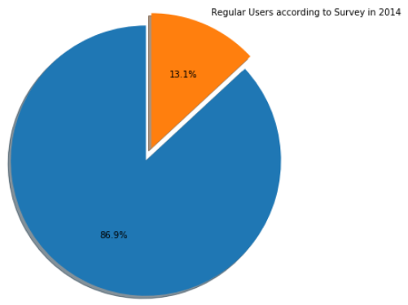
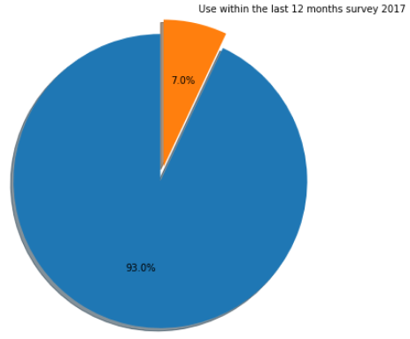

Fig.4a,b: Percentages for the consumption of cannabis in Colorado (left) and Germany (right).

With the tax revenues on cannabis in the first year (Feb-Dec) having been 67,594,323 $ [2] we can calculate an estimate for the tax revenues in Euros for the first year for Germany if Germany were to legalize and tax recreational marijuana. For that we need the population of Germany in the year of legalization (in this case we choose 2019), which is 83 Millions [5] and of Colorado in 2014 – 5.25 Million. Beyond that we need our proportional consumption estimator that is the estimated proportion of consumers in Germany in the year of legalization (in this case 2019) – 7% - divided by the estimated consumers of Colorado in 2014 – 13%. This estimator helps us create a more conservative and also more reliable estimate. In the end we need to multiply by (12/11) because we want to calculate the estimate for an entire year and we multiply with the rate of euros to dollars (currently 0.901):

67,594,323 $ x (83.0 Millions/ 5.25 Million) x (7%/13%) x 0.901
=
565,580,000 €

This number represents a broad estimate that may help seeing the dimensions within which tax revenues on taxed recreational consumption may be. To create a more precise estimate the prices of licensed production and sale of cannabis would have to be compared and the proportional consumption estimator would have to include more aspects of consumption.
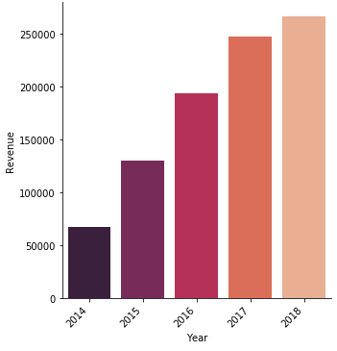
Considering that the sales and therefore the tax revenues evolved a lot within the first years of legalization until starting to converge to a ceiling, it is to be expected that sales and revenues would similarly evolve in other countries. Using the same formula as before but canceling the proportional consumption estimator for the later years, we would yield 1 Billion Euros for the second year and 1.48 Billion Euros for the 3rd year before eventually ceiling after probably 5 years.
These calculations show the fiscal potential of such taxes.

[1] – Eurostat: https://ec.europa.eu/eurostat
[2] – Department of revenue of Colorado- https://www.colorado.gov/pacific/revenue/colorado-marijuana-tax-data
[3] – Department of public health and environment of Colorado - https://www.colorado.gov/pacific/cdphe/marijuanause
[4] – Survey by Aerzteblatt - https://www.aerzteblatt.de/medizin/wissenschaft?aid=209388
[5] – Population of Germany - https://www.destatis.de/DE/Themen/Gesellschaft-Umwelt/Bevoelkerung/Bevoelkerungsstand/_inhalt.html
[6] – Population of Colorado - https://www.codot.gov/projects/north-i-25/NorthI-25/additional-information/tiger/news-articles/colorado-population-2016

